Make Human – to - Mixamo – to - FBX2GG

To make custom character models to use in Game Guru.

Instructions by - Pirate Myke
and Rafhalzer

Edited by – Len the man

This guide will describe the basic processes to get a character from MakeHuman, thru Mixamo animations, and into the FBX2GG program for custom characters.
You will need:
(1) Make Human program
(2) A Mixamo Account for adding animations
(3) The FBX2GG program
You will not need:
Any 3d programs for this (like Blender).
Open MakeHuman and make you character as you please.
Make sure you have the following setting when complete.

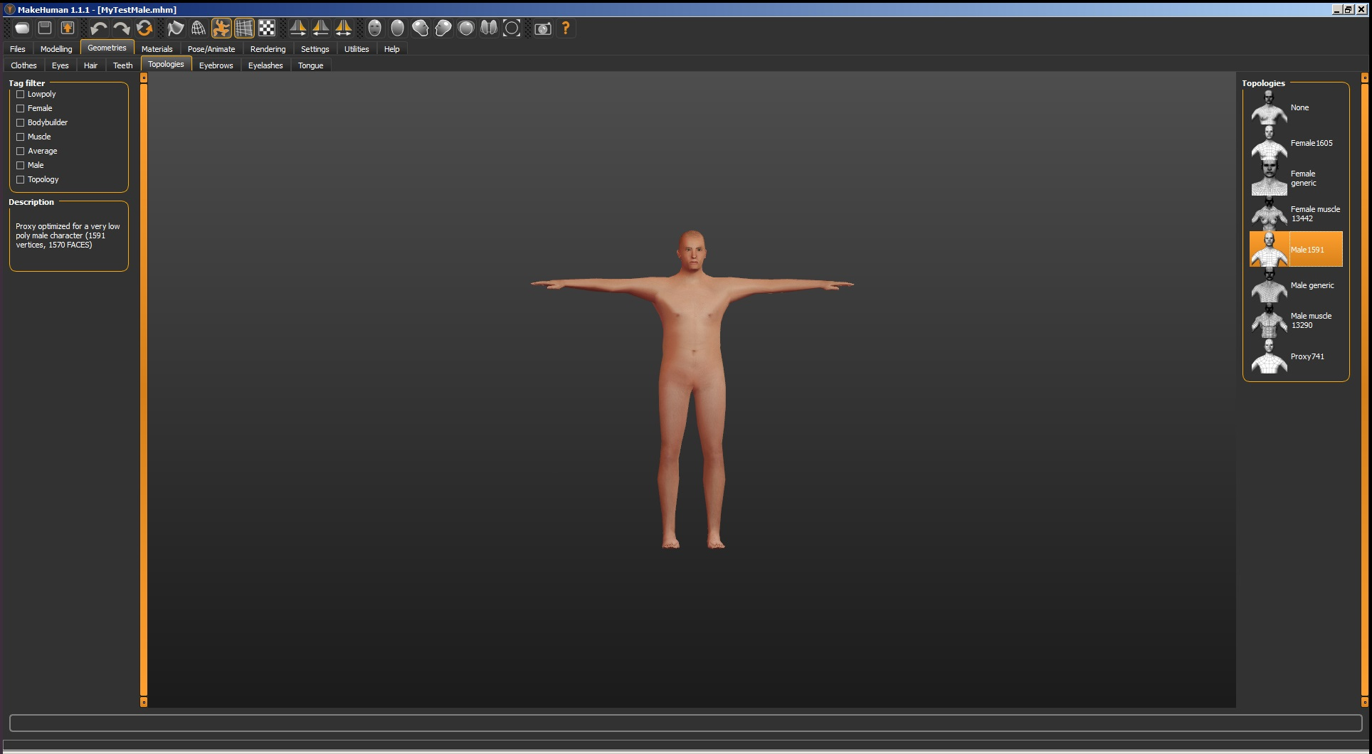

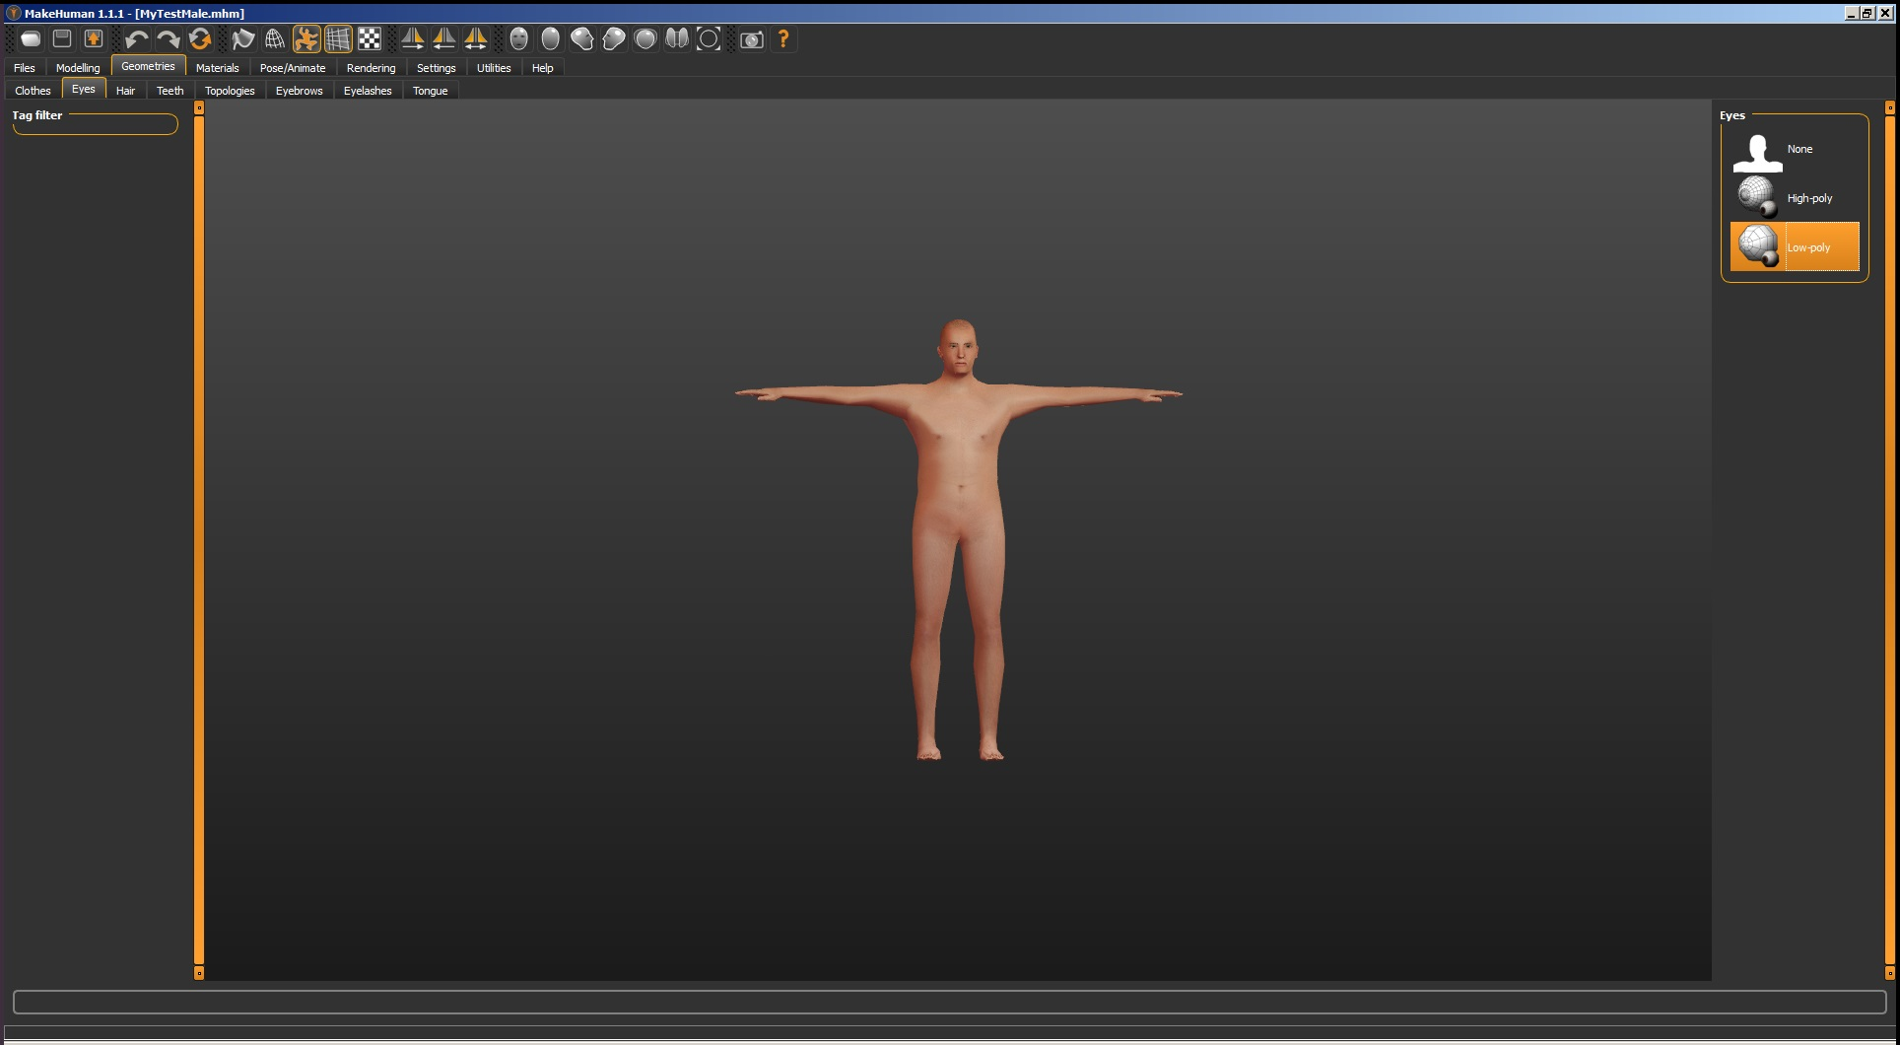

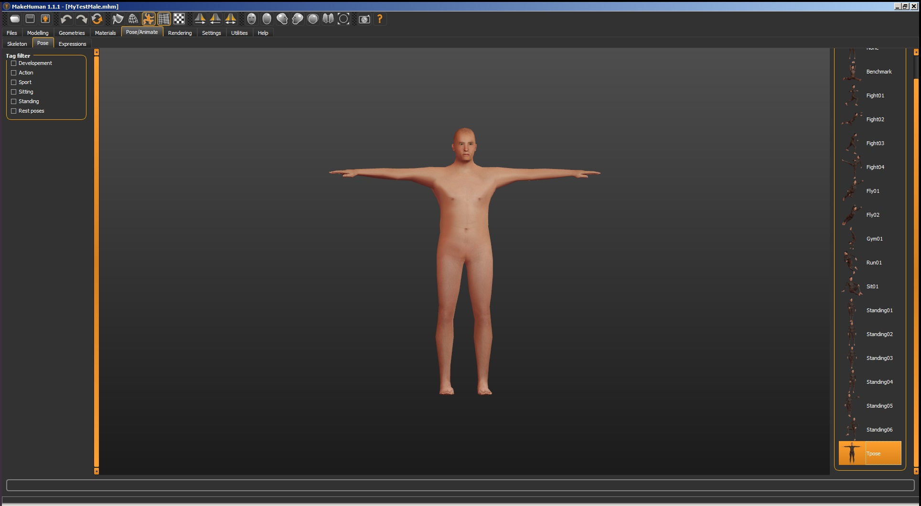
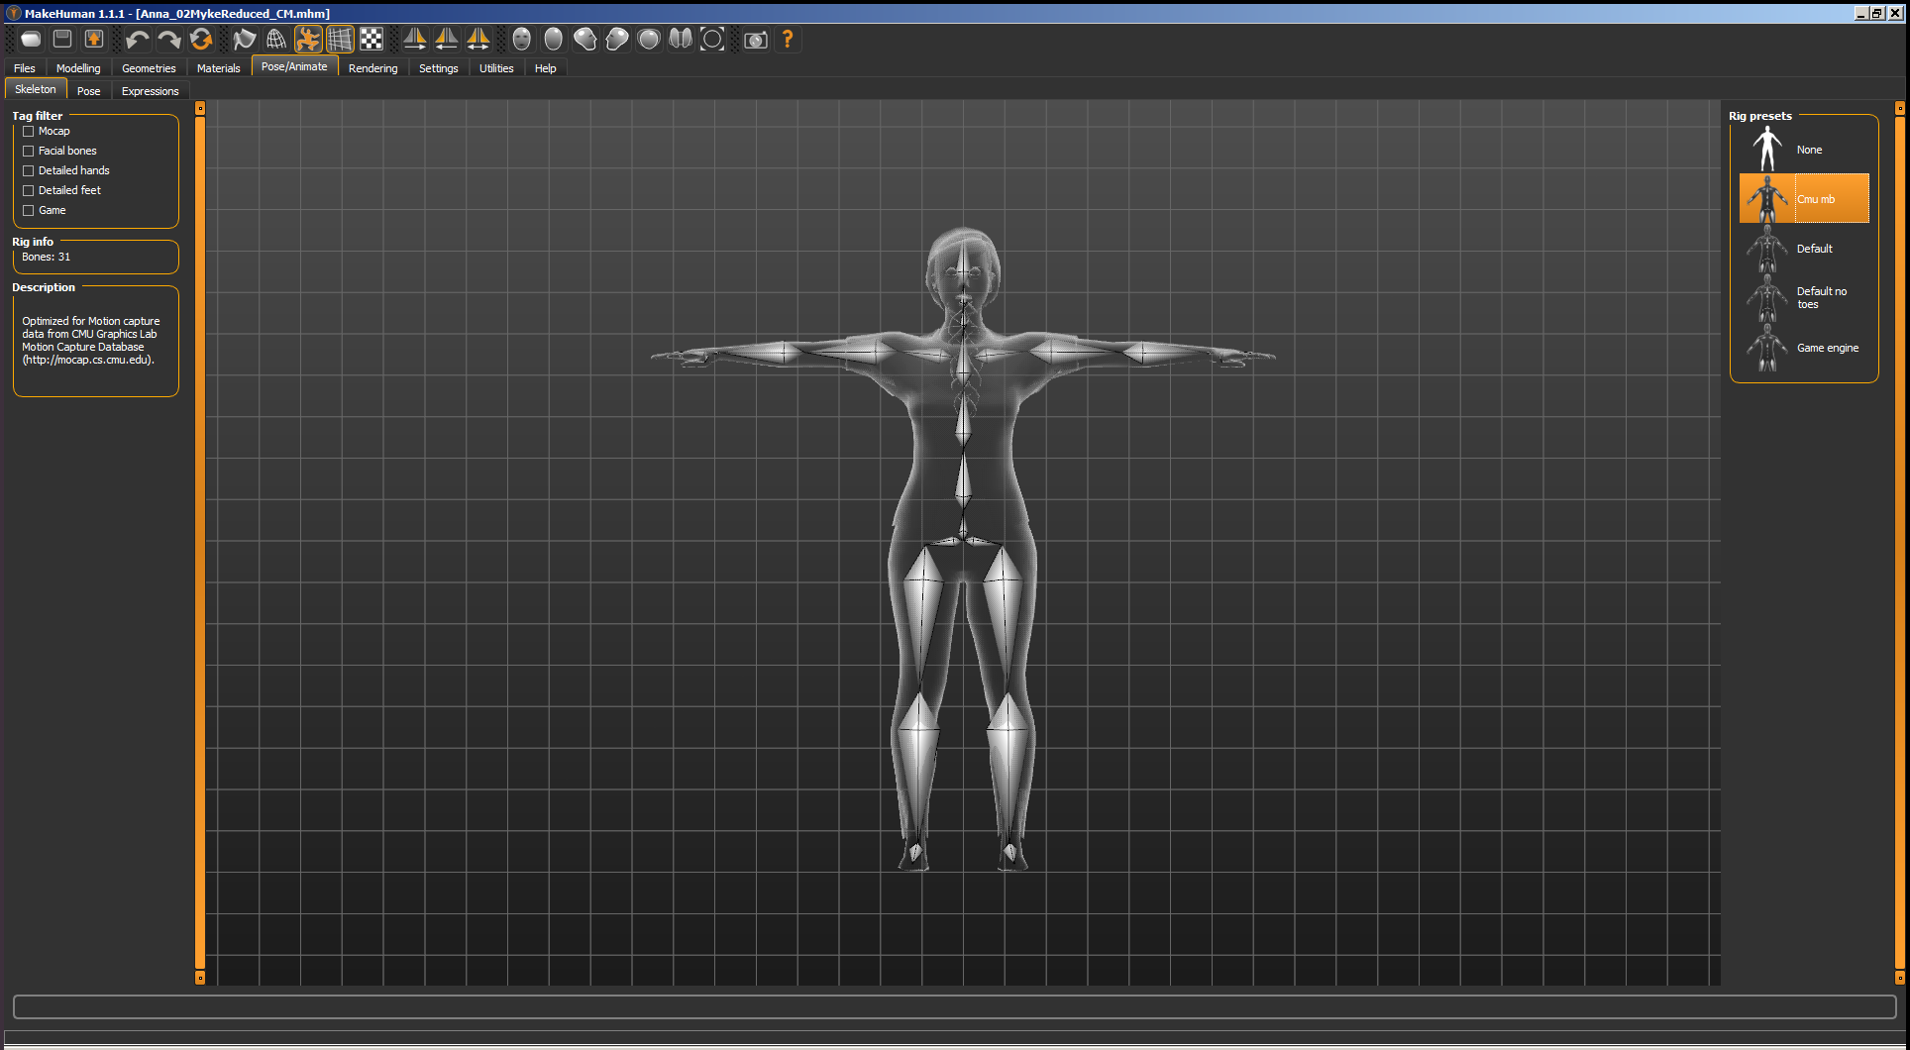
Using these setting shown above will prevent you from having to mess with it in a 3d model program. This model comes in at 13006 polys.
Export this with these settings:

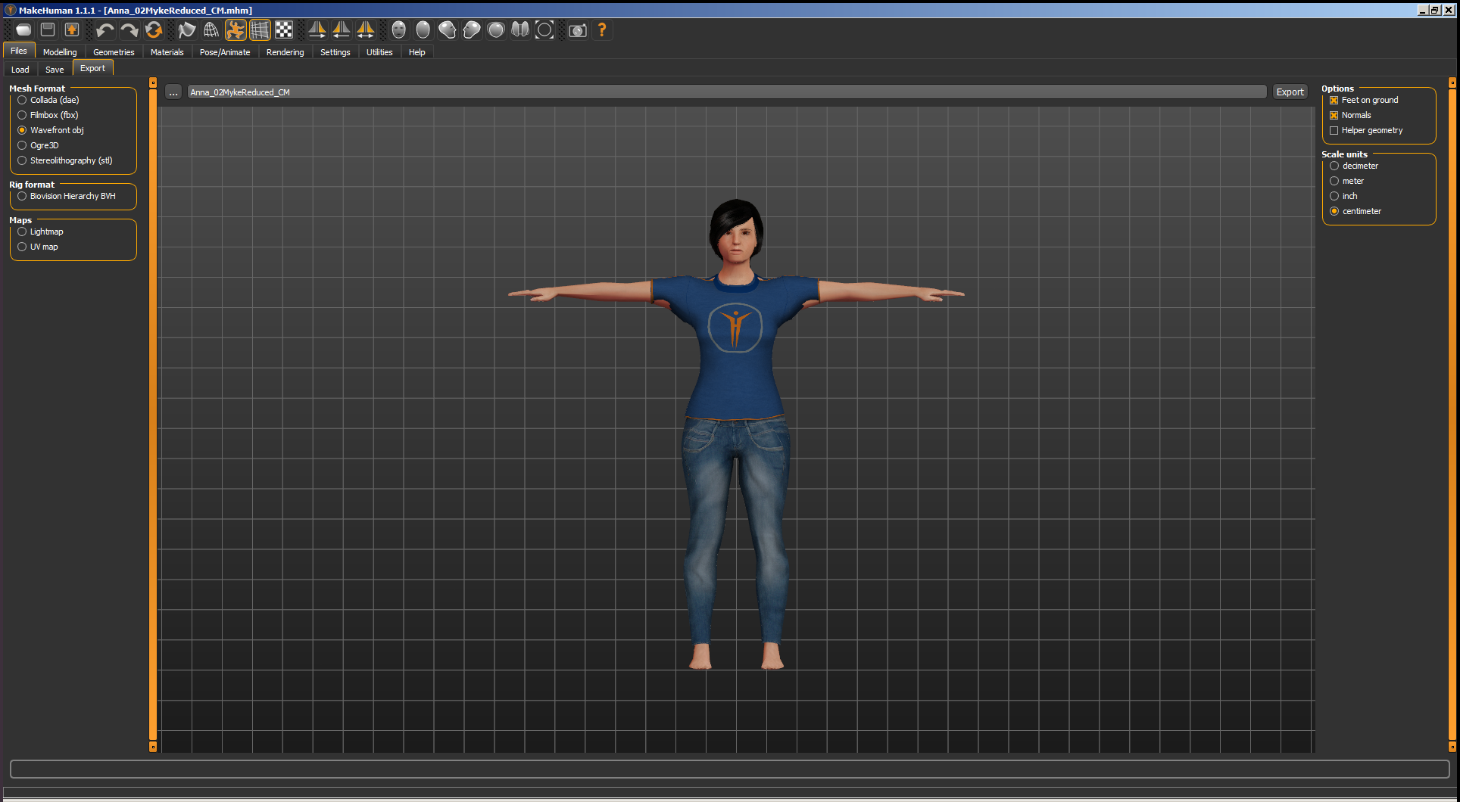

Log into Maxamo.
Drag your .obj file to the upload character screen.
Set the auto rig settings as follows.

Apply your animations and keep them in place for standard character types.

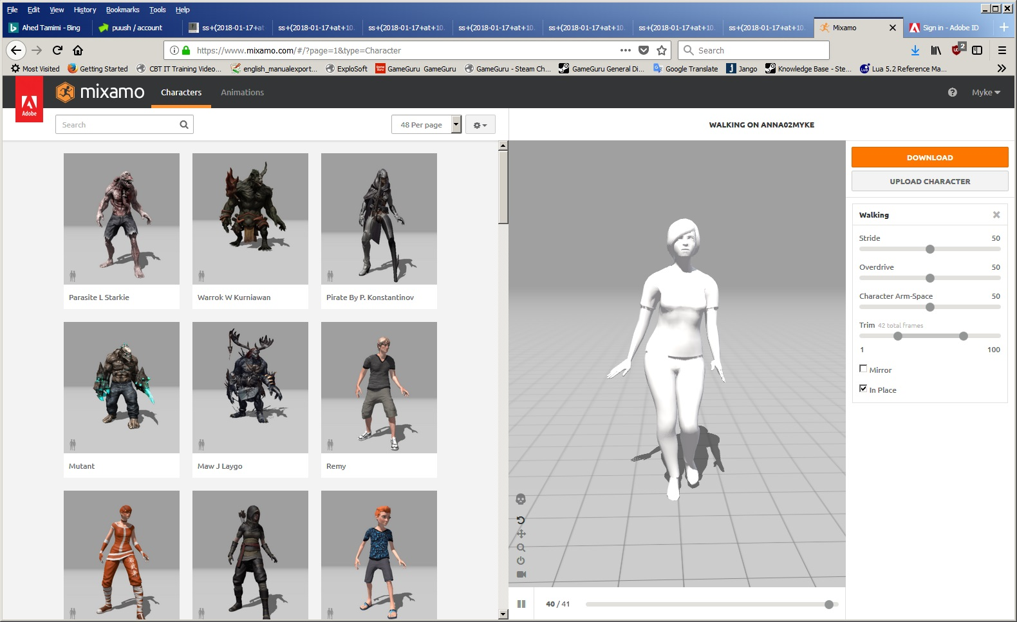
Download 2 versions of the character, one with skin and one without skin. The one without skin is for the animation.

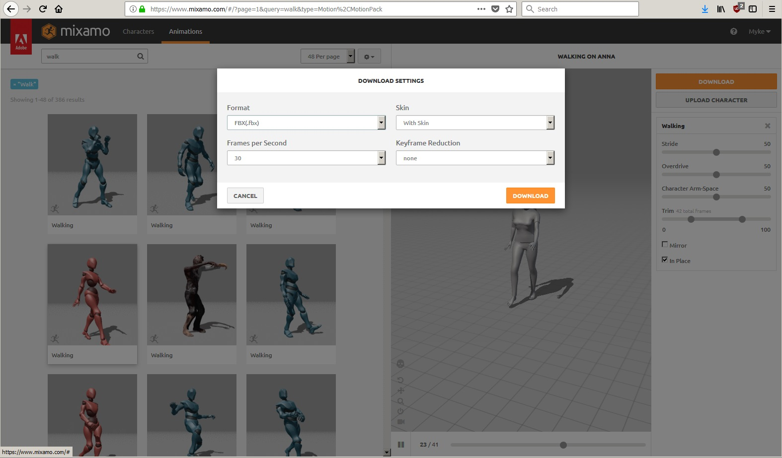

Making a Makehuman model to upload to Mixamo with skin included:

Makehuman exports to .obj, .mtl, and texture files.
You will need to modify the .mtl file first.
Makehuman exports the textures to the folder called "textures", which is within the exports folder. The texture files should be copied and put in the same folder as the .mtl and .obj files and not in the folder labeled "textures".
Open the .mtl file in a text editor (or you can use Notepad ++) and find the path to all texture files, for example:
map_Kd textures\short04_diffuse.png

There should be a few similar lines, and they all need to be changed.
You should modify it to the following:
map_Kd short04_diffuse.png

Notice that you should delete the part in the middle, which is “textures\”.
Save the .mtl file and zip all files (.mtl, .obj, and all texture files). Make sure your zip file is in the export folder, and make sure it isn't in a subfolder.
Now load the .zip file into Mixamo.

If it loads with all the skins correctly, it should look like the cowboy model by Len the man:

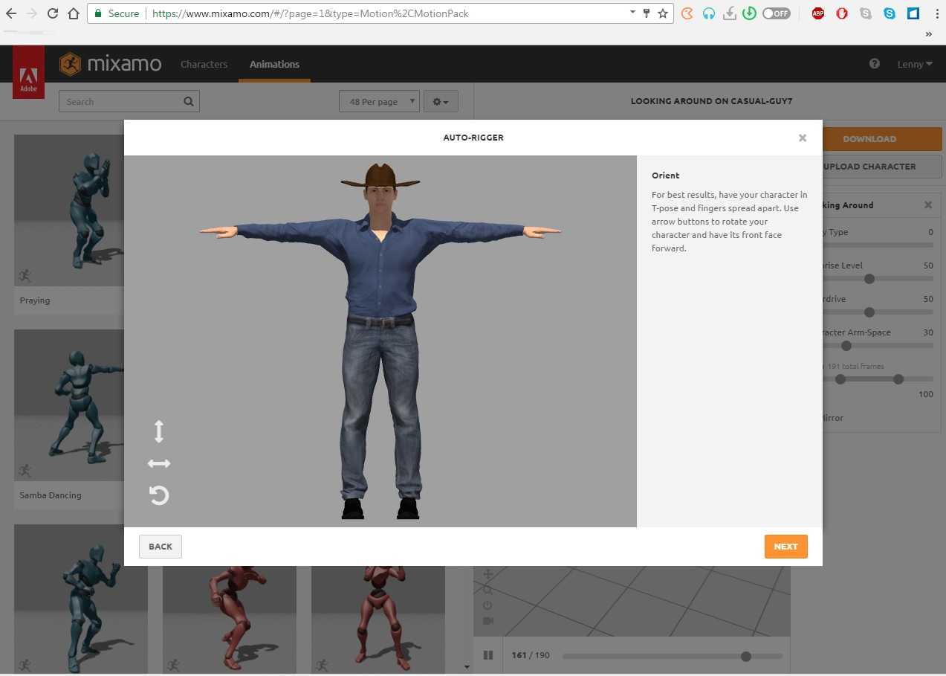

When each one is done (with and without skin), rename it so the next will not over write it.
Next, open FBX2GG.
Open the FBX file with the mesh.

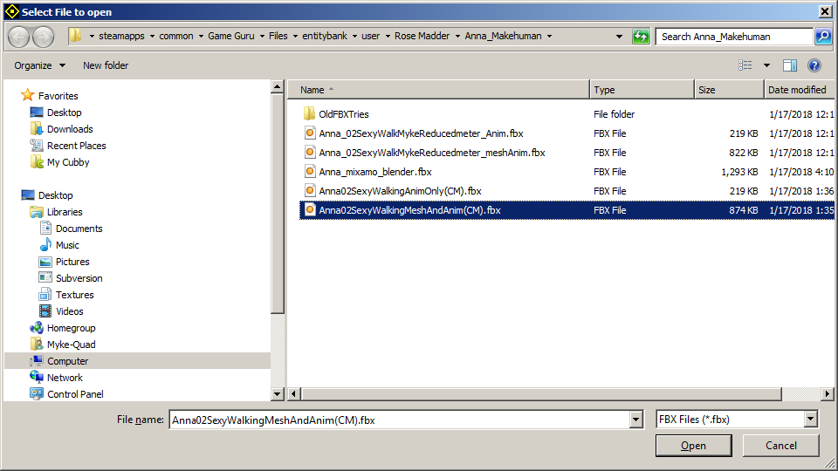
It should look like this. Don't worry that the textures are not showing. It is not important right now.

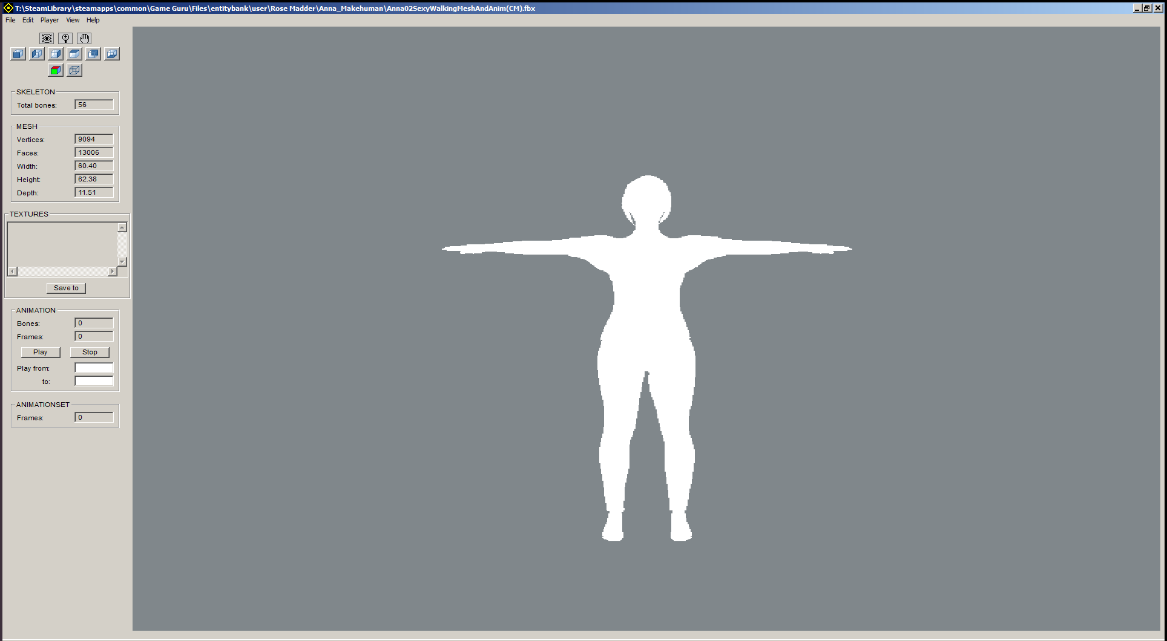
Press <edit> and then <prepare skeleton for FBX animations>.
Press <edit> then <Import FBX animations> and then choose the FBX without the skin.

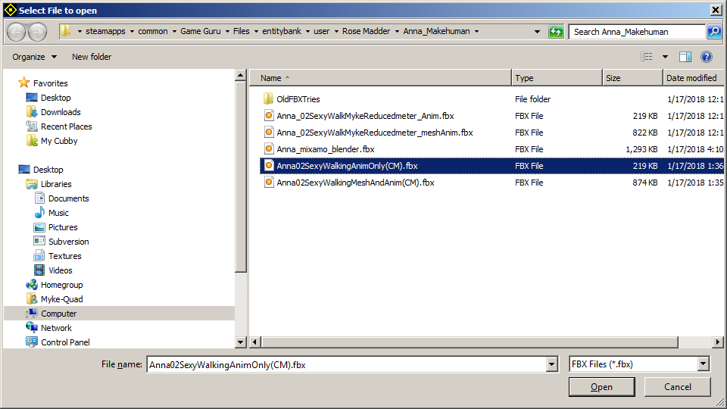
It will look like this.

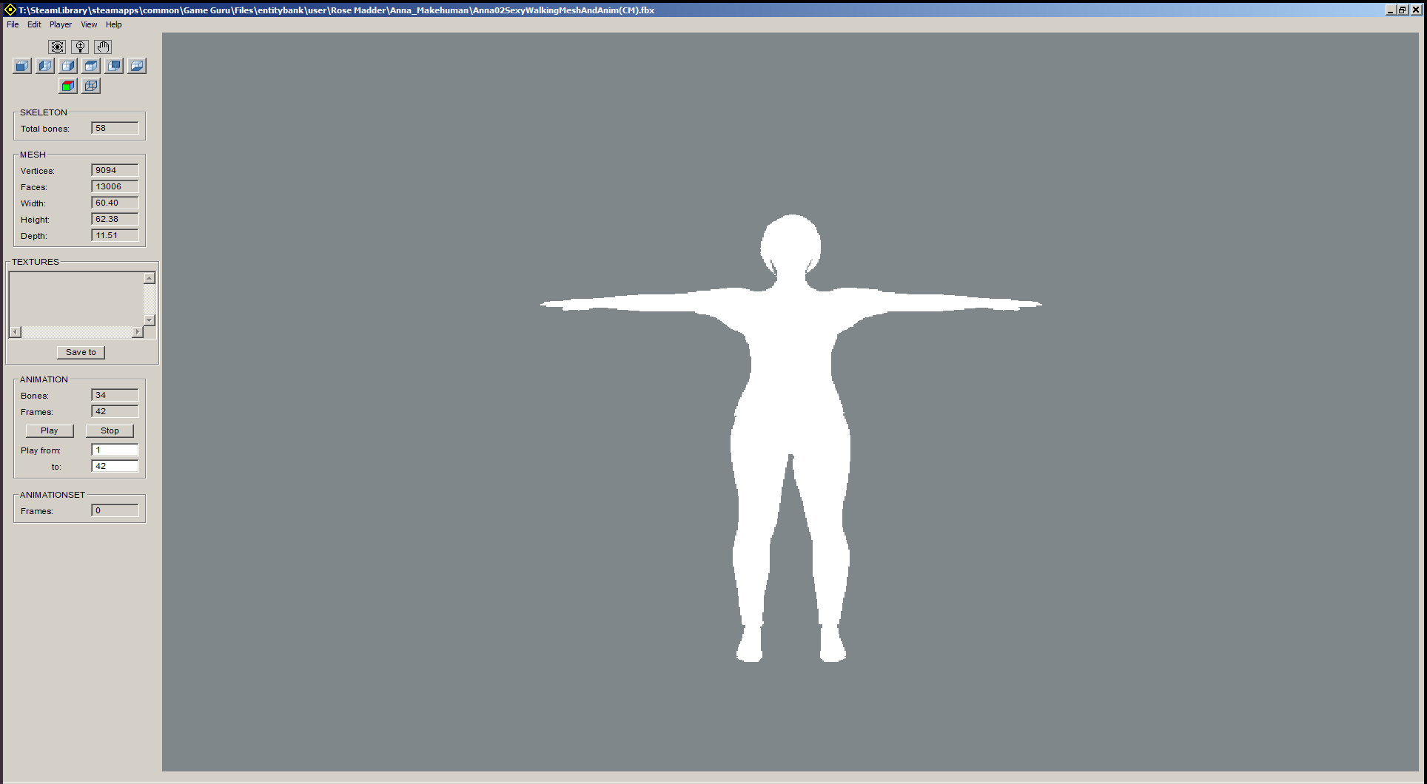

Press <edit> and then <Add FBX animation to animation set>.

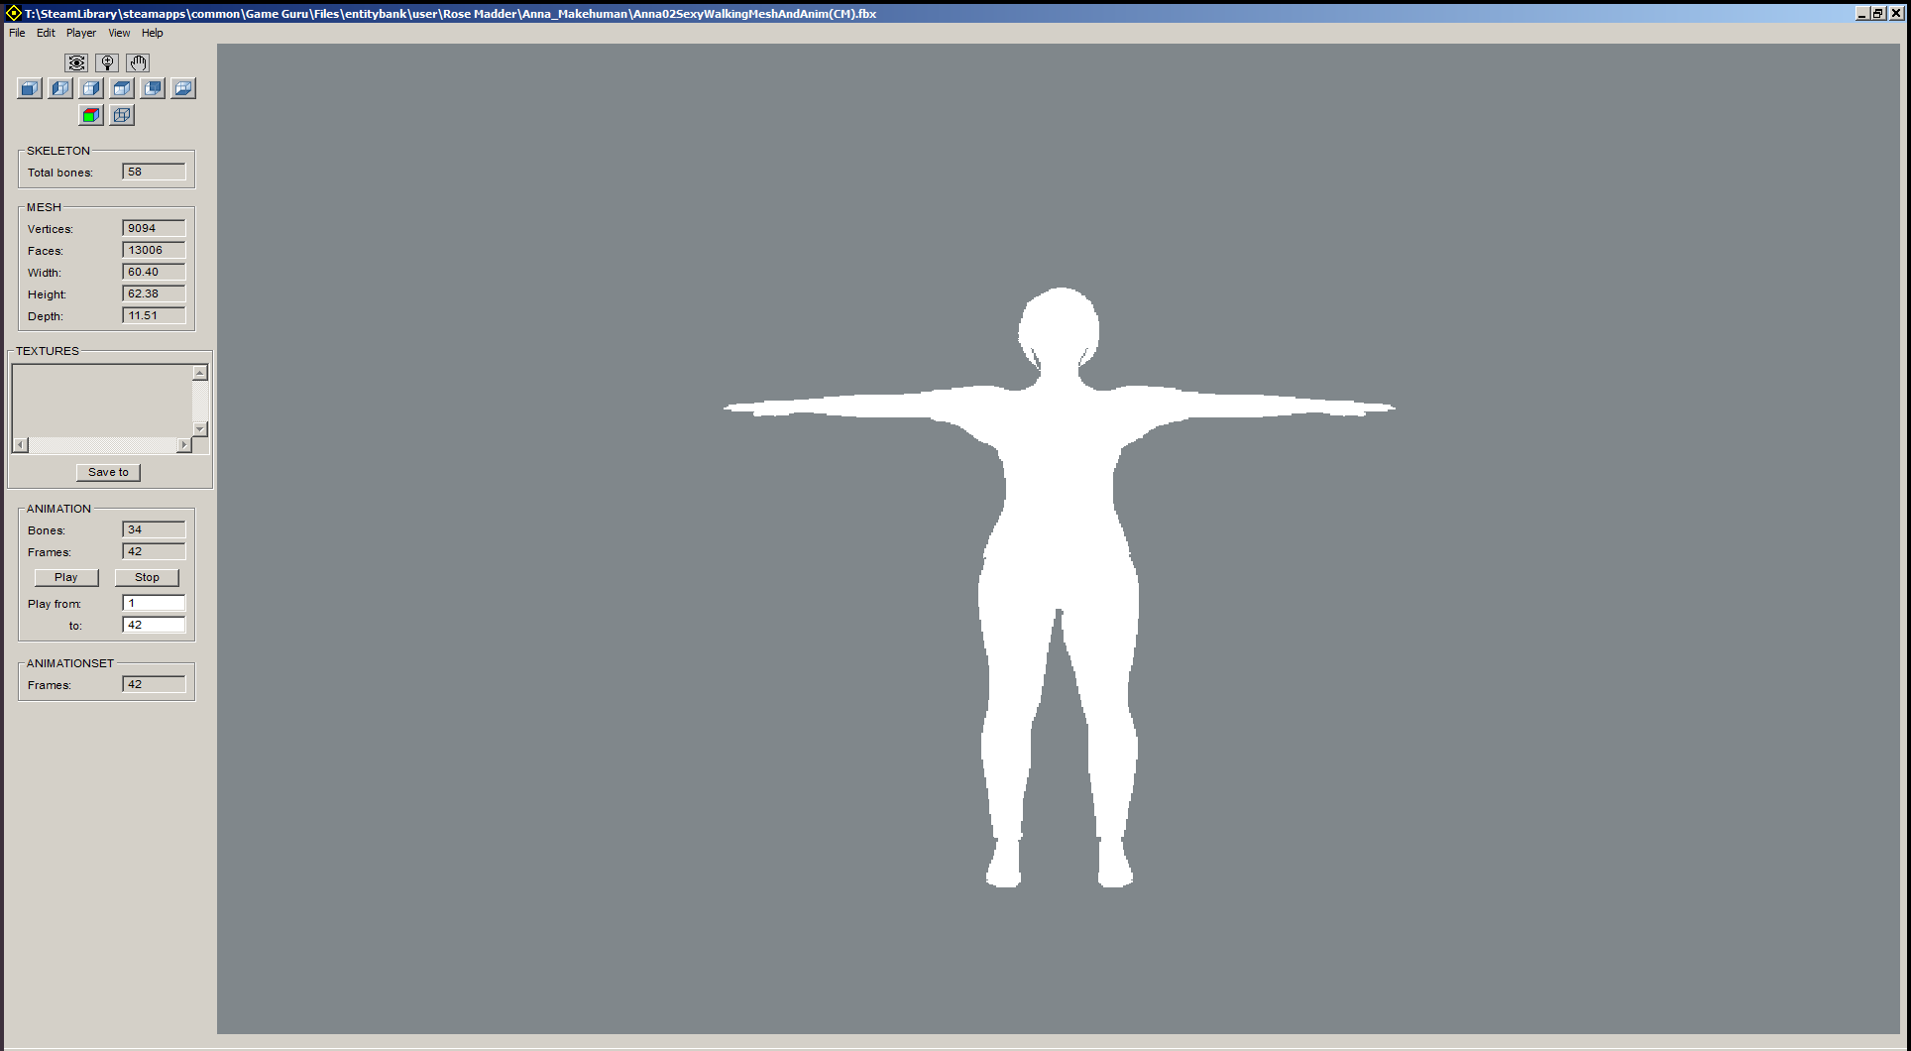
Press <File> and then <save as DirectX with animation set>.

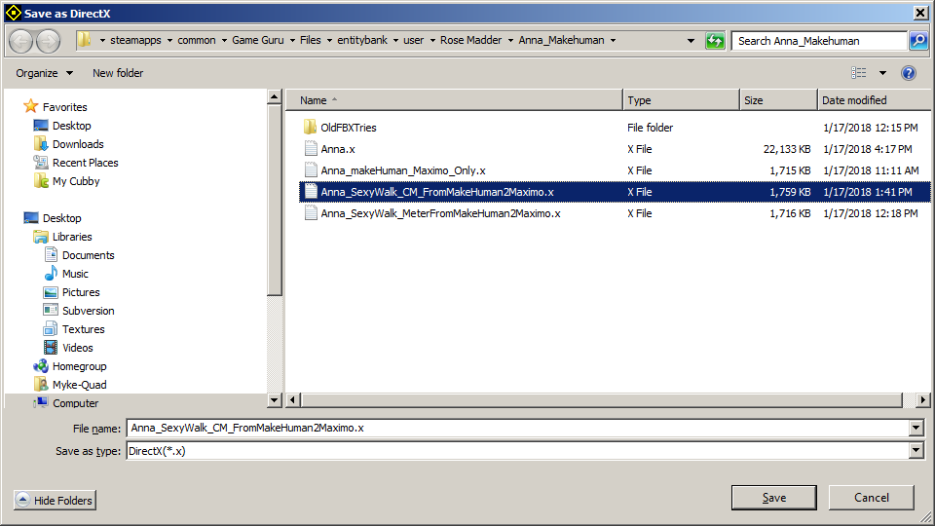
Press Save button to export it with animations.
Place the X file, textures all in the same folder.
Modify a FPE file like the one shown below. Changing the names of the mesh and textures to match your new character. It should look something like this.

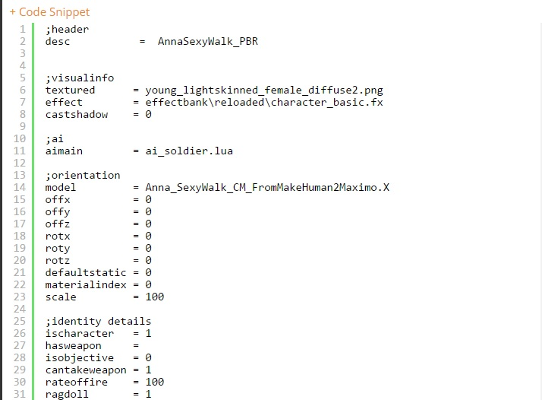
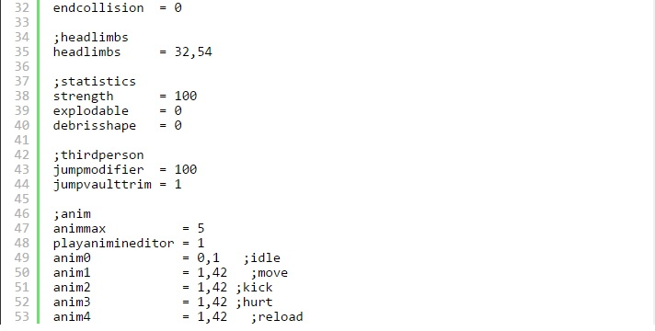
If you wish to copy this FPE, you can copy, cut and paste the one listed below or on the next page.
;header
desc = AnnaSexyWalk_PBR

;visualinfo
textured = young_lightskinned_female_diffuse2.png
effect = effectbank\reloaded\character_basic.fx
castshadow = 0

;ai
aimain = ai_soldier.lua

;orientation
model = Anna_SexyWalk_CM_FromMakeHuman2Maximo.X
offx = 0
offy = 0
offz = 0
rotx = 0
roty = 0
rotz = 0
defaultstatic = 0
materialindex = 0
scale = 100

;identity details
ischaracter = 1
hasweapon =
isobjective = 0
cantakeweapon = 1
rateoffire = 100
ragdoll = 1
endcollision = 0

;headlimbs
headlimbs = 32,54

;statistics
strength = 100
explodable = 0
debrisshape = 0

;thirdperson
jumpmodifier = 100
jumpvaulttrim = 1

;anim
animmax = 5
playanimineditor = 1
anim0 = 0,1 ;idle
anim1 = 1,42 ;move
anim2 = 1,42 ;kick
anim3 = 1,42 ;hurt
anim4 = 1,42 ;reload

Save the FPE file and test the character in Game Guru.
You will need to script it for your needs.

Remember that you should use Notepad ++ or similar software to work on an FPE file like this.

To get a better view of some of the pictures and diagrams you may wish to visit the forum in order to click on the pictures. These instruction, pictures, and diagrams are located at the following link:

https://forum.game-guru.com/thread/219217

